**Air quality forecasting using statistical and machine learning methods**

**Filling the empty records**

Empty records filled using exponential smoothing in Excel. The damping factor kept constant i.e., 0.8. This means that the value for alpha = 1 - damping factor = 1 - 0.8 = 0.2

**D. 16/02/2022. Experimentation 1: Finding the perfect function**

1. **Moving Average**

Following table is the comparisons of various moving average estimator configurations. The value for M = 2 gives the minimum Mean Squared Error (MSE) value.

|  |  |  |  |  |
| --- | --- | --- | --- | --- |
| **Method** | **Mean estimator** | **MA, M = 2** | **MA, M = 3** | **MA, M = 5** |
| **Mean Squared Error** | 5896 | 631 | 1274 | 2349 |

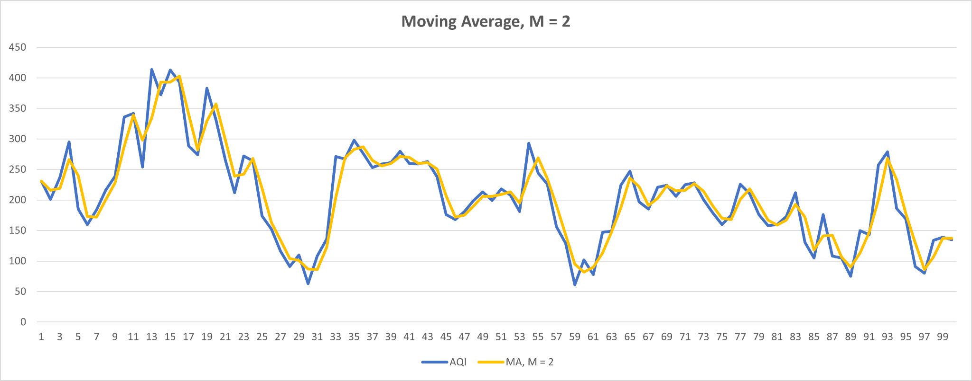

1. **Exponential Smoothing**

Following table is the comparisons of various moving average estimator configurations. The value for ɑ = 0.9 gives the minimum Mean Squared Error (MSE) value. Still, the MSE achieved in the MA method is far better.

|  |  |  |  |  |  |
| --- | --- | --- | --- | --- | --- |
| **Ɑ value** | **0.2** | **0.3** | **0.5** | **0.8** | **0.9** |
| **Mean Squared Error** | 3955 | 3411 | 2834 | 2522 | 2519 |

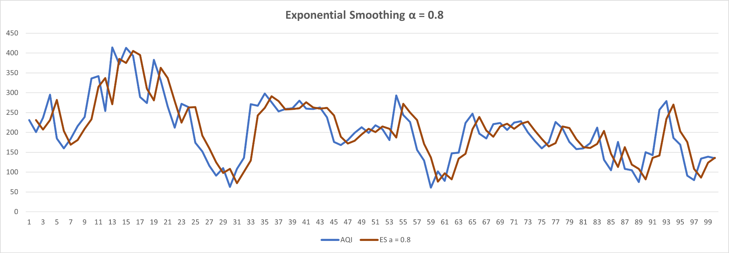

1. **Double Exponential Smoothing**

Following table is the experimentation for finding Mean Squared Error using all possible values of ɑ and Ƴ. The value pair for (ɑ, Ƴ) = (1, 0.1)

|  |  |  |  |  |  |  |  |  |  |  |  |
| --- | --- | --- | --- | --- | --- | --- | --- | --- | --- | --- | --- |
| **Ɑ \ Ƴ** | **0.0** | **0.1** | **0.2** | **0.3** | **0.4** | **0.5** | **0.6** | **0.7** | **0.8** | **0.9** | **1** |
| **0.0** | 3131318 | * | * | * | * | * | * | * | * | * | * |
| **0.1** | 86205 | 9433 | 7160 | 7340 | 8036 | 9306 | 8238 | 8862 | 8753 | 10265 | 10581 |
| **0.2** | 24739 | 4103 | 3788 | 3965 | 4098 | 4569 | 4420 | 4430 | 4455 | 4553 | 4471 |
| **0.3** | 11824 | 2443 | 2338 | 2426 | 2416 | 2585 | 2534 | 2611 | 2687 | 2758 | 2766 |
| **0.4** | 6836 | 1516 | 1443 | 1492 | 1546 | 1624 | 1639 | 1695 | 1739 | 1785 | 1838 |
| **0.5** | 4461 | 962 | 913 | 947 | 981 | 1079 | 1096 | 1172 | 1239 | 1318 | 1382 |
| **0.6** | 2995 | 604 | 569 | 609 | 665 | 769 | 813 | 887 | 969 | 1084 | 1172 |
| **0.7** | 2125 | 370 | 358 | 412 | 478 | 586 | 667 | 773 | 886 | 1017 | 1157 |
| **0.8** | 1542 | 216 | 233 | 310 | 402 | 530 | 644 | 790 | 949 | 1137 | 1327 |
| **0.9** | 1170 | 145 | 192 | 293 | 421 | 585 | 747 | 951 | 1171 | 1435 | 1732 |
| **1** | 927 | **132** | 217 | 358 | 535 | 755 | 994 | 1294 | 1640 | 2062 | 2573 |

Refining the values of ɑ and Ƴ further

|  |  |  |  |  |  |  |  |  |  |  |  |
| --- | --- | --- | --- | --- | --- | --- | --- | --- | --- | --- | --- |
| **Ɑ \ Ƴ** | **0.090** | **0.091** | **0.092** | **0.093** | **0.094** | **0.095** | **0.096** | **0.097** | **0.098** | **0.099** | **0.1** |
| **0.95** | 129 | 131 | * | 132 | 133 | 132 | 128 | * | 130 | 131 | 134 |
| **0.96** | 130 | * | 128 | 130 | * | 131 | 126 | * | 129 | 130 | 136 |
| **0.97** | 130 | 131 | **125** | * | 128 | * | 129 | * | 128 | 129 | 130 |
| **0.98** | 126 | * | * | 127 | 128 | 127 | 129 | 128 | 132 | 128 | 129 |
| **0.99** | **125** | 127 | * | 128 | 131 | 132 | 129 | * | 128 | 128 | 131 |
| **1** | 128 | * | 131 | 132 | 131 | * | 127 | 129 | 132 | * | 2573 |

Best pair of ɑ and Ƴ are (0.97, 0.092) and (0.99, 0.090)

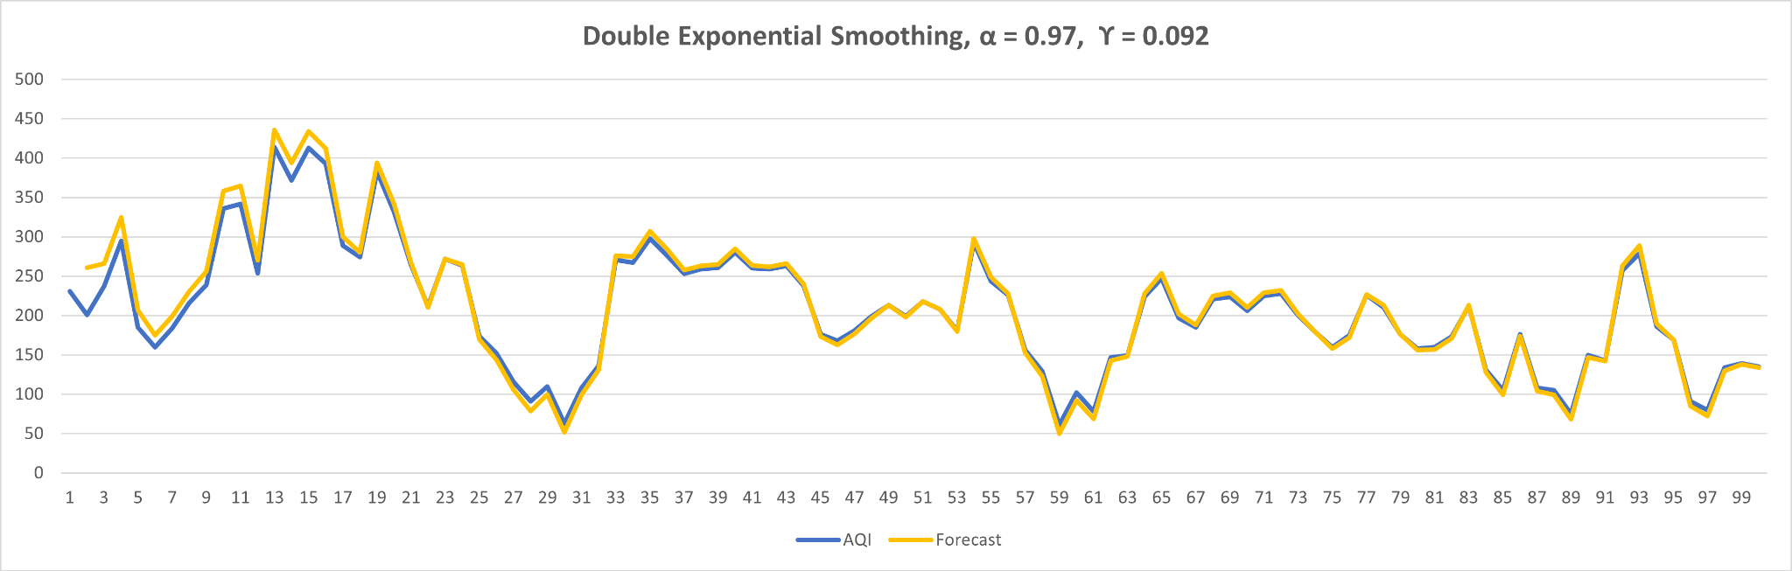

1. **Forecasting the AQI for next 30-days using previous double exponential smoothing**

|  |  |
| --- | --- |
| **Mean Squared error** | **3148** |

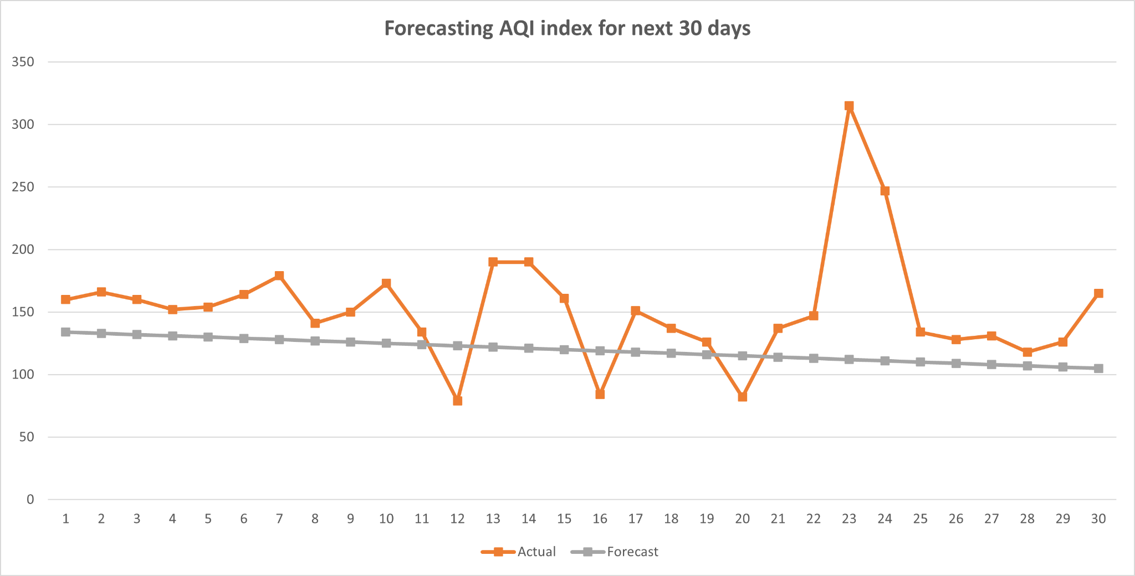

1. **Finding the standard deviation**

We calculate the standard deviation by first finding the variance (The square of the deviation of X value from mean). Later we sum-up all variances, divide them by N - 1 and take its square root.

|  |  |
| --- | --- |
| **Standard Deviation** | 77 |

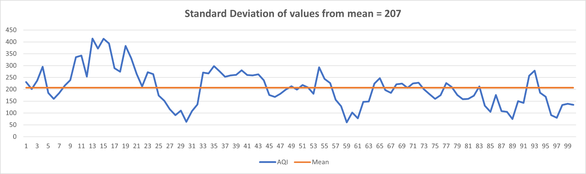

**Up and down bars representing the deviation of each data point from the mean of the whole data series.**

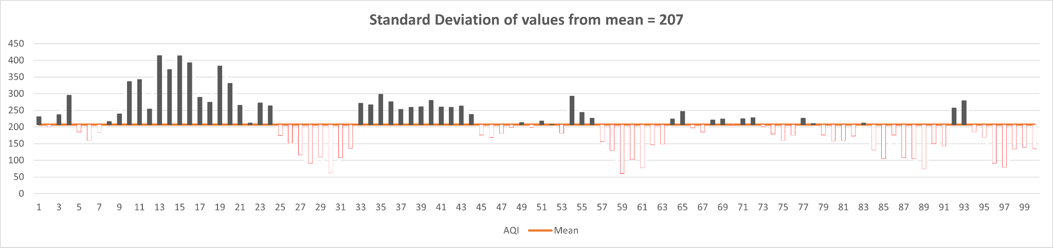

D. 24/02/2022, Thursday

New experiment: Imputation of time series (Filling the missing values)

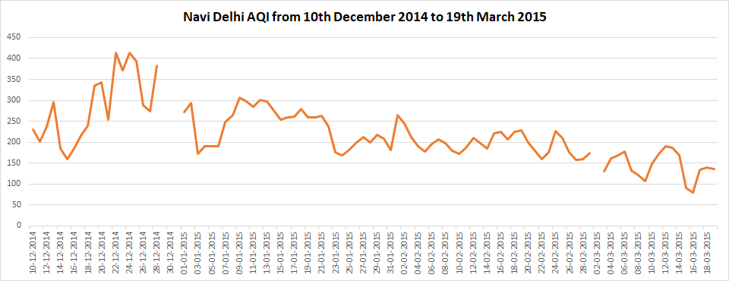

|  |  |
| --- | --- |
| **Total observations** | 2476 |
| **Missing observations out of total** | 142 |
| **% of missing observations out of total** | 5.7 |

